


(TOTAL HEALTHCARE SOLUTIONS PROVIDER)

P. O. Box GP 2821 |  | Email: beautifulcreationsgh@yahoo.com
Accra - Ghana |  | bcclgh@gmail.com
Tel: (233) 0302 667171, Hotline: 0243111199 |  | Website: www.bcmedicals.com
Your Ref: | Our Ref: | Date: 9TH February, 2026

Sealed Quotation No: My Ref: GHS/RHB/26/AW/PQ/NM/1Q

BOLGATANGA REGIONAL HOSPITAL
P. O. BOX 26,
BOLGATANGA,
UPPER EAST REGION

SUPPLY, DELIVERY OF NON-MEDICINES CONSUMABLES

- Bid Form

- Price Schedule

- Company Certificates

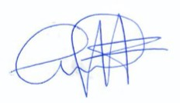
Yours faithfully,

…………………
Kwaku Ansong
Managing Director

